2023
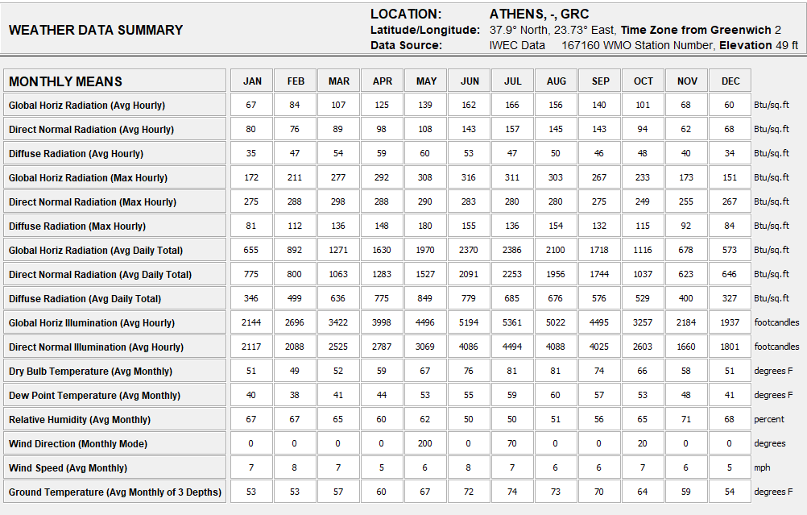
COMFORT MODELS:
Human Thermal comfort can be defined primarily by dry bulb temperature and humidity, although different sources have slightly different definitions. Select the model you wish to use:
© California Energy Code Comfort Model, 2013 (DEFAULT)
For the purpose of sizing residential heating and cooling systems the indoor Dry Bulb Design Conditions should be between 68°F (20°C) to 75°F (23.9°C). No Humidity limits are specified in the Code, so 80% Relative Humidity and 66°F (18.9°C) Wet Bulb is use for the upper limit and 27°F (-2 8°C) Dew Point is used for the lower limit (but these can be changed on the Criteria screen)
O ASHRAE Standard 55 and Current Handbook of Fundamentals Model
Thermal comfort is based on dry bulb temperature, clothing level (clo), metabolic activity (met), air velocity, humidity, and mean radiant temperature. Indoors it is assumed that mean radiant temperature is close to dry bulb temperature. The zone in which most people are comfortable is calculated using the PM (Predicted Mean Vote) model In residential settings people adapt clothing to match the season and feel comfortable in higher air velocities and so have wider comfort range than in buildings with centralized HVAC systems
• ASHRAE Handbook of Fundamentals Comfort Model up through 2005
For people dressed in normal winter clothes, Effective Temperatures of 68°F (20°C) to 74°F (23 3°C) (measured at 50% relative humidity), which means the temperatures decrease slightly as humidity rises. The upper humidity limit is 64°F (17 8°C) Wet Bulb and a lower Dew Point of 36F (2 2°C). If people are dressed in light weight summer clothes then this comfort zone shifts 5'F (2 8°C)
• Adaptive Comfort Model in ASHRAE Standard 55-2010
In naturally ventilated spaces where occupants can open and close windows, their thermal response will depend in part on the outdoor climate, and may have a wider comfort range than in buildings with centralized HVAC systems This model assumes occupants adapt their clothing to thermal conditions, and are sedentary (1 0 to 1.3 met) There must be no mechanical Cooling System, but this method does not apply if a Mechanical Heating System is in operation
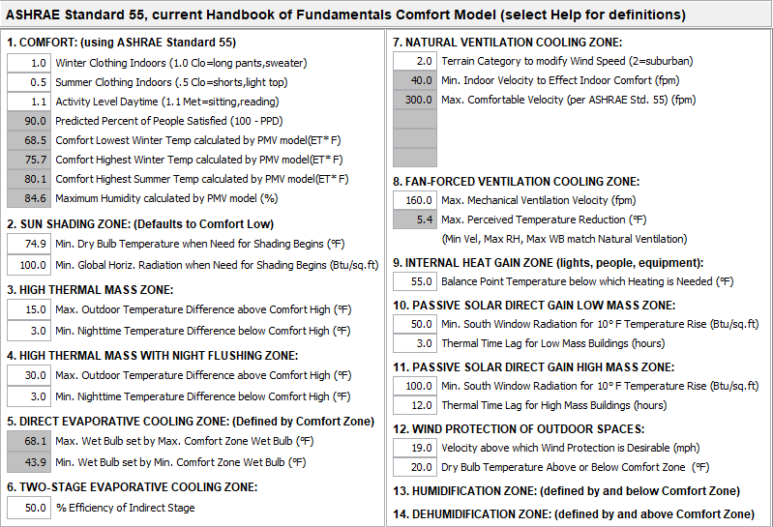

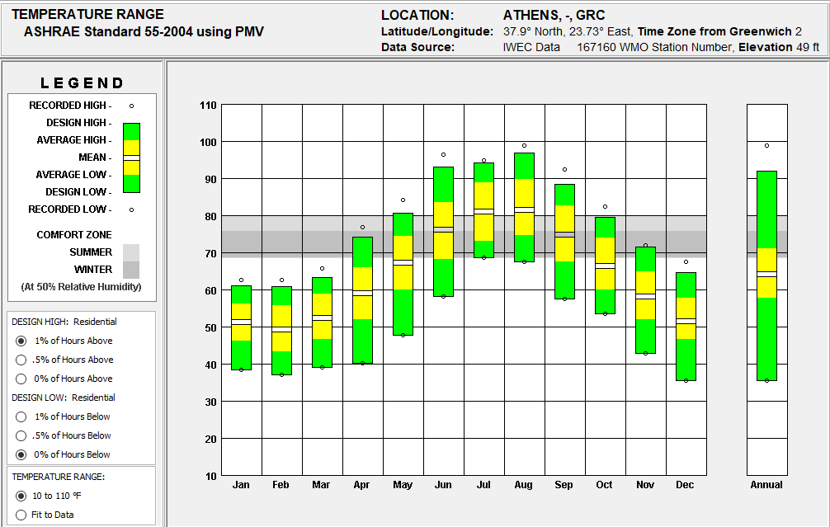
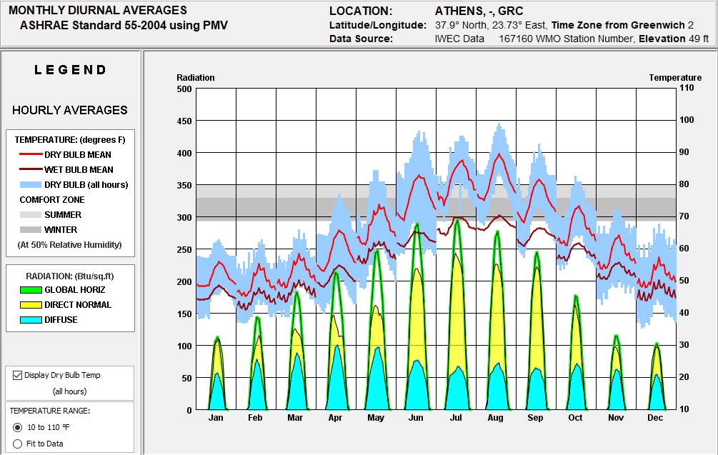

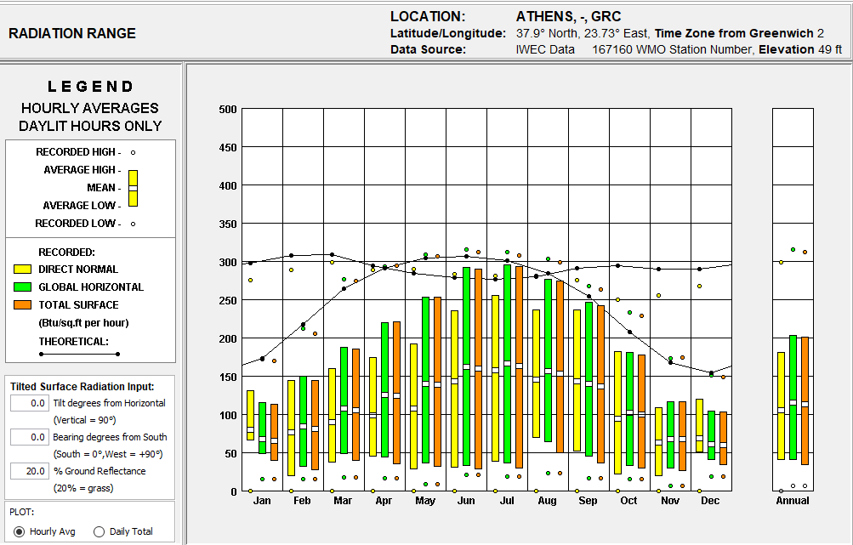
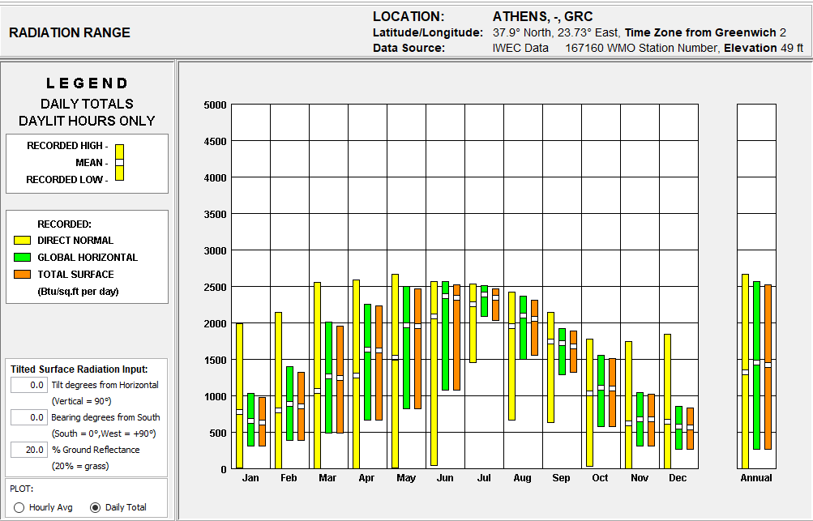

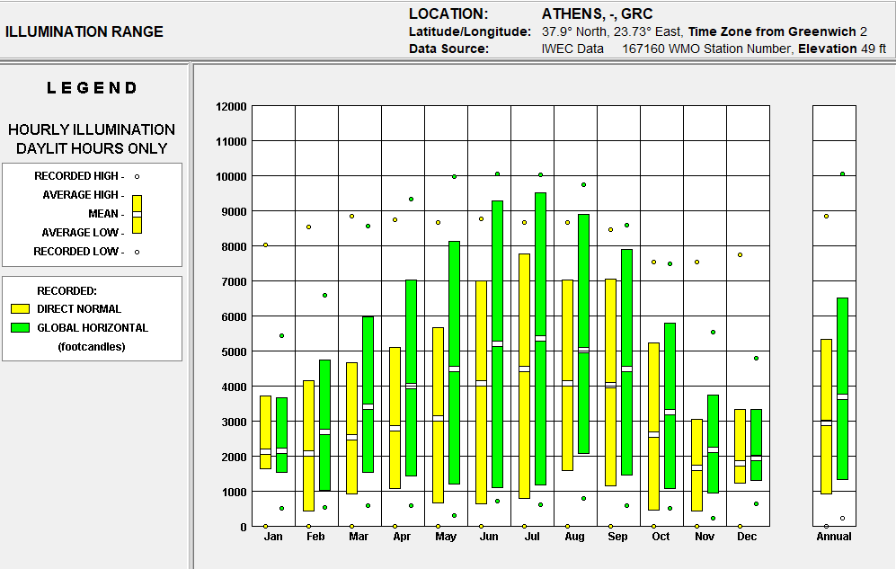
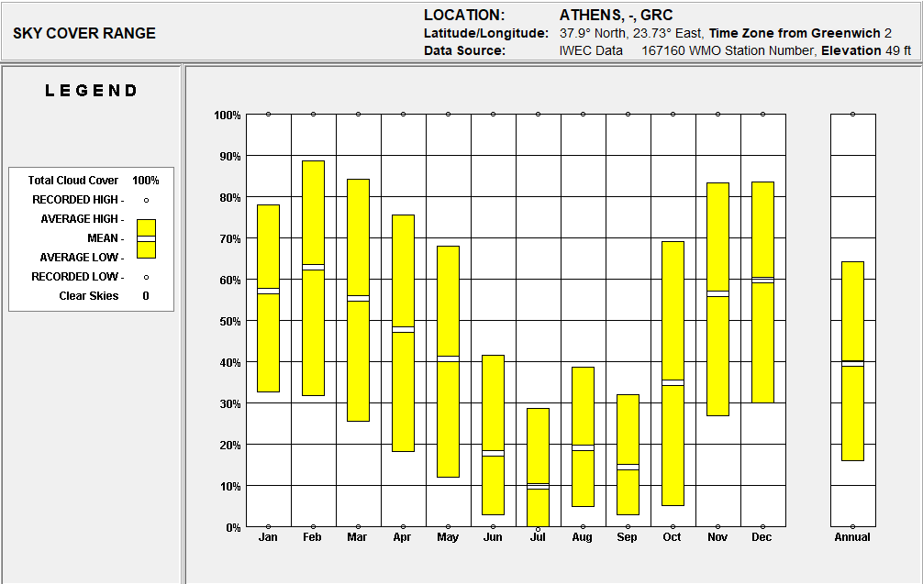

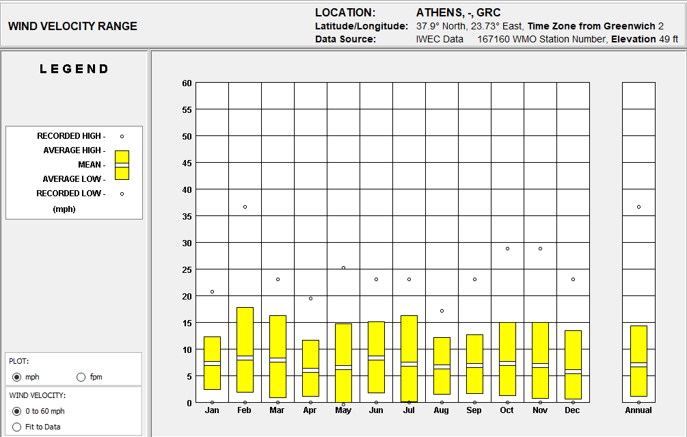

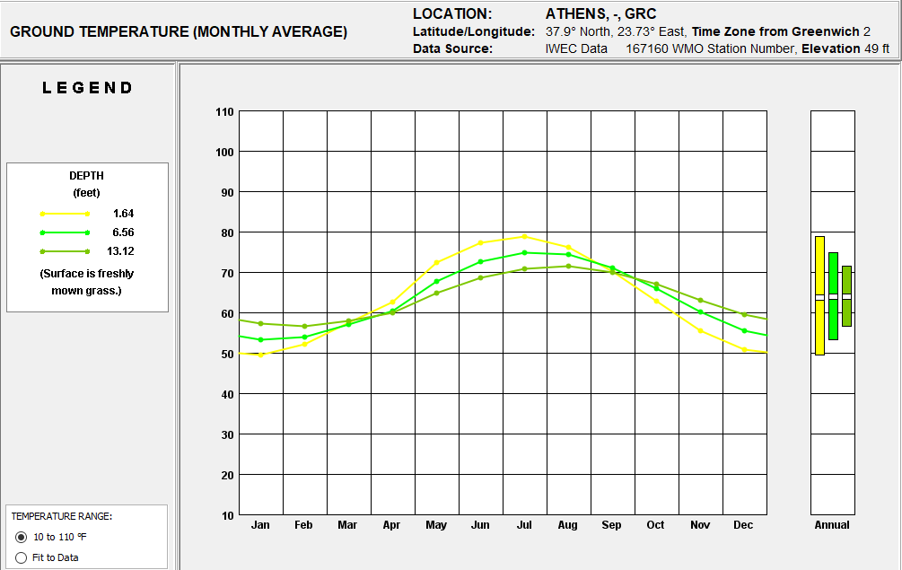
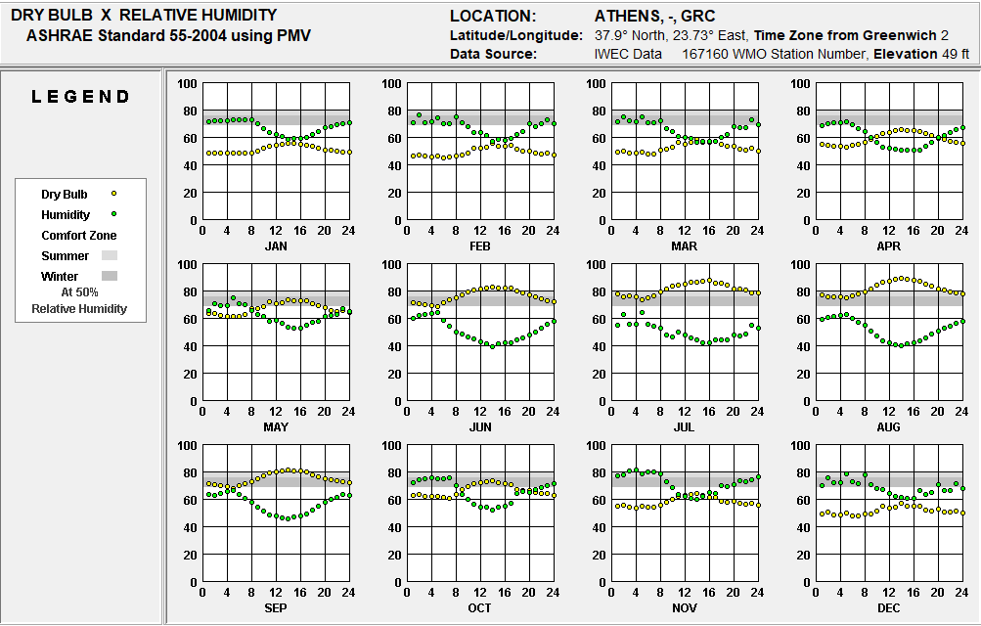
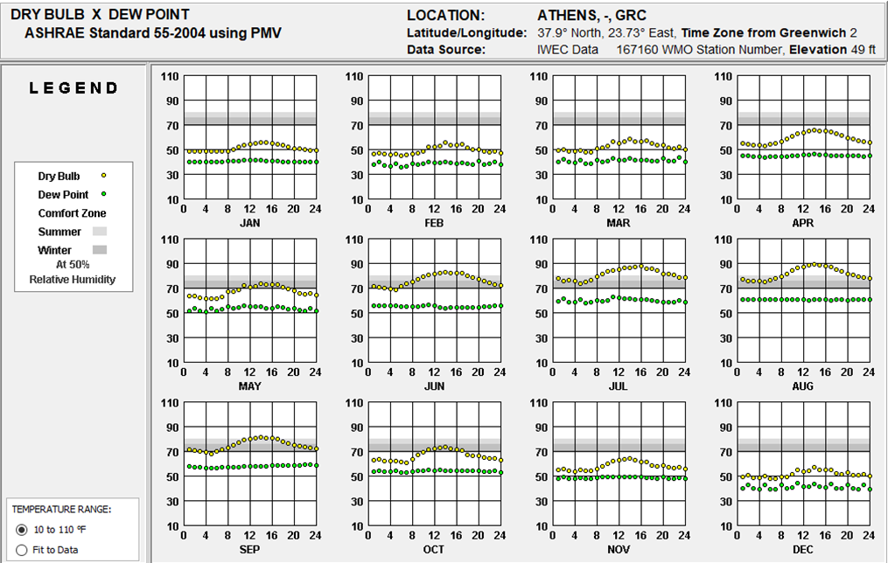

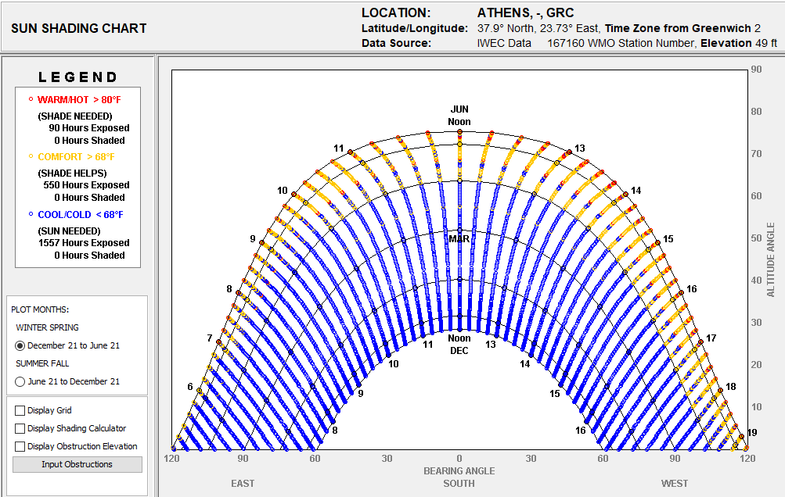
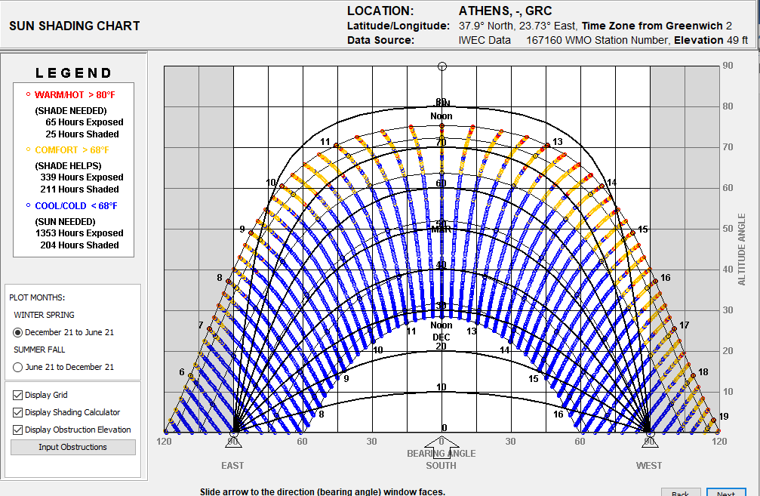
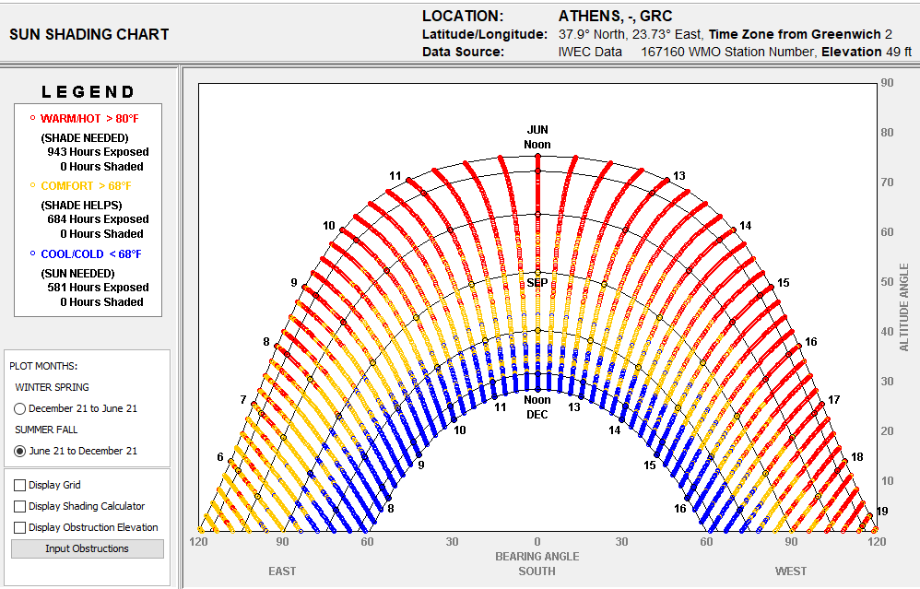
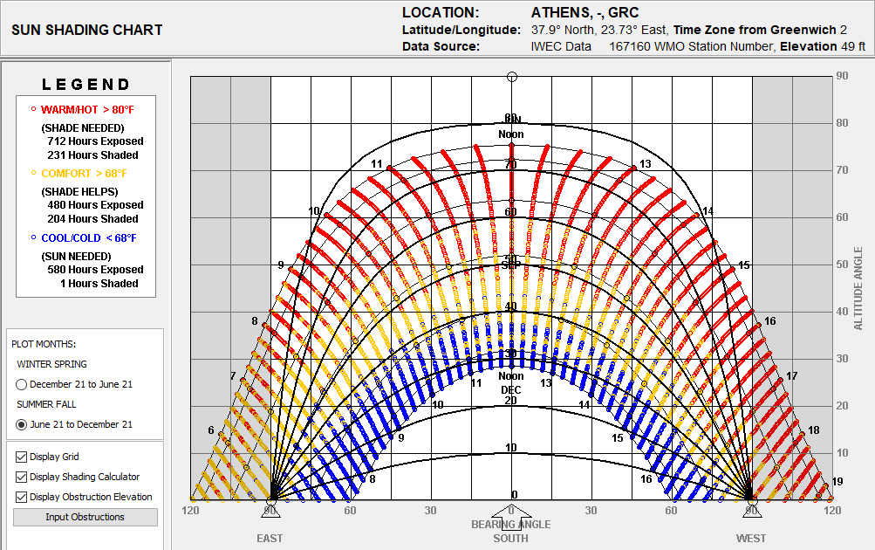

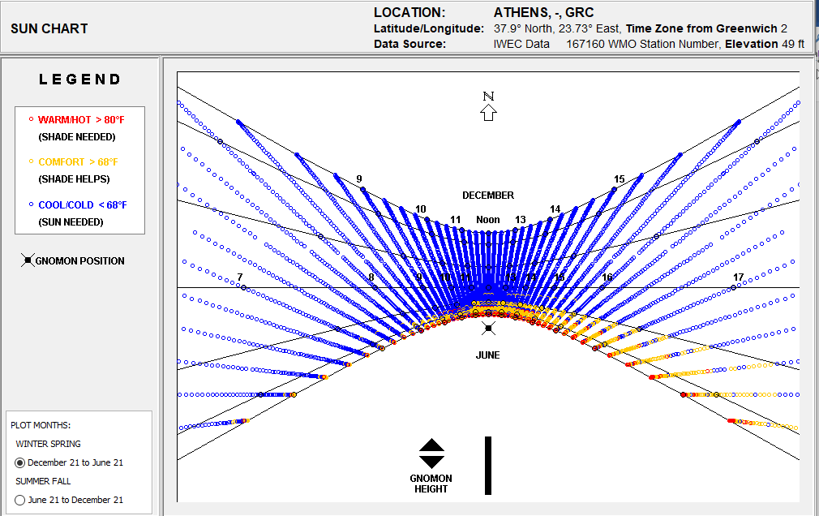
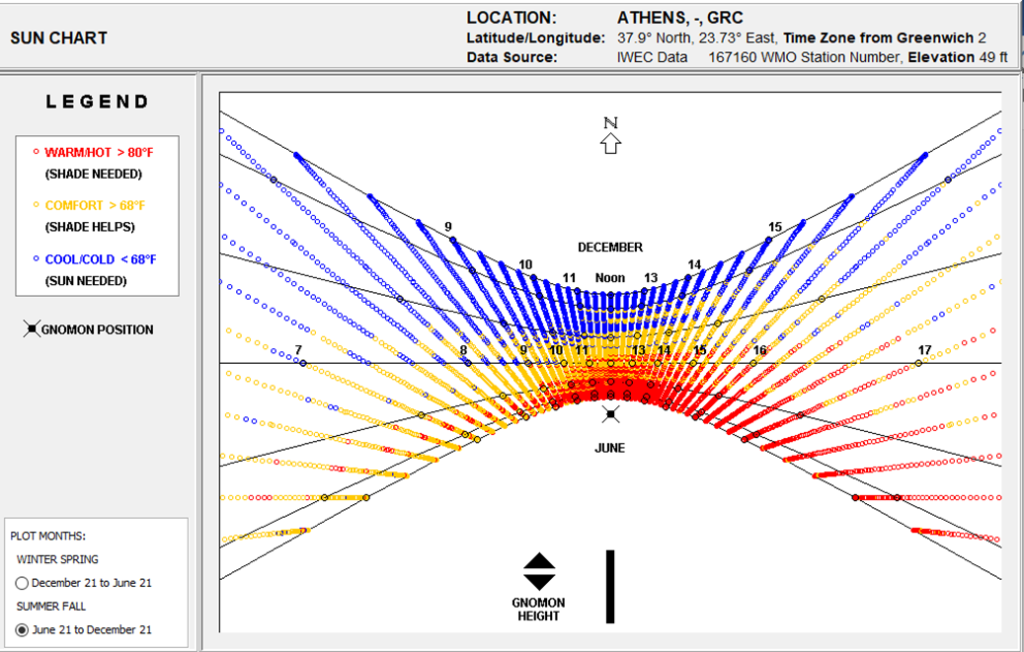
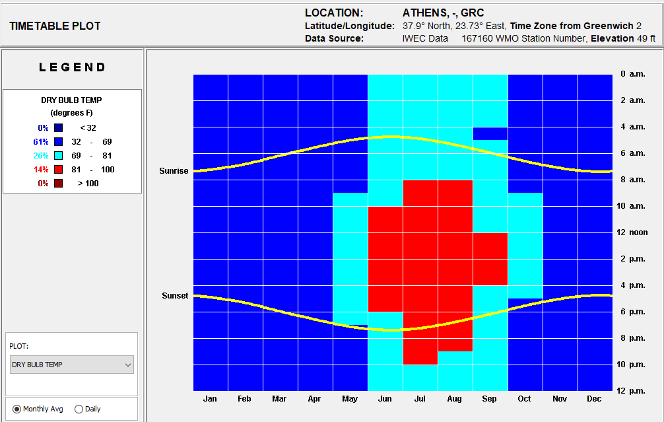
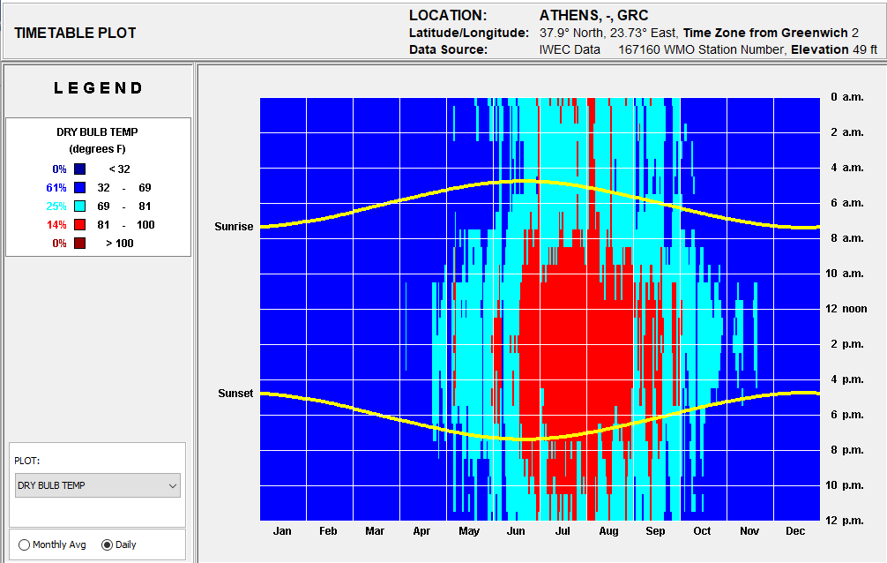
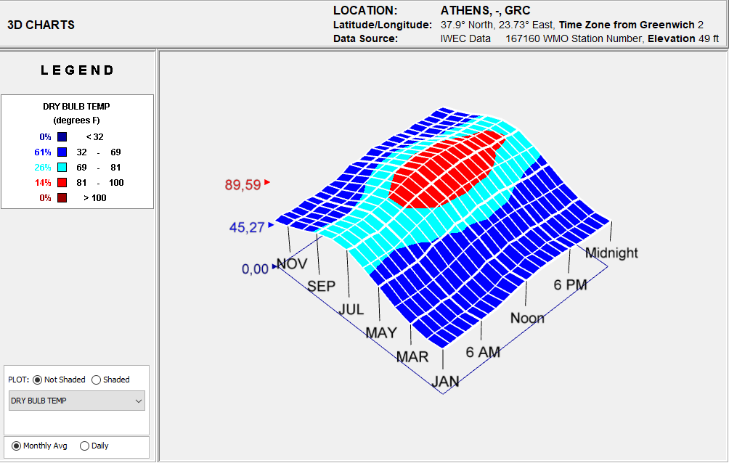
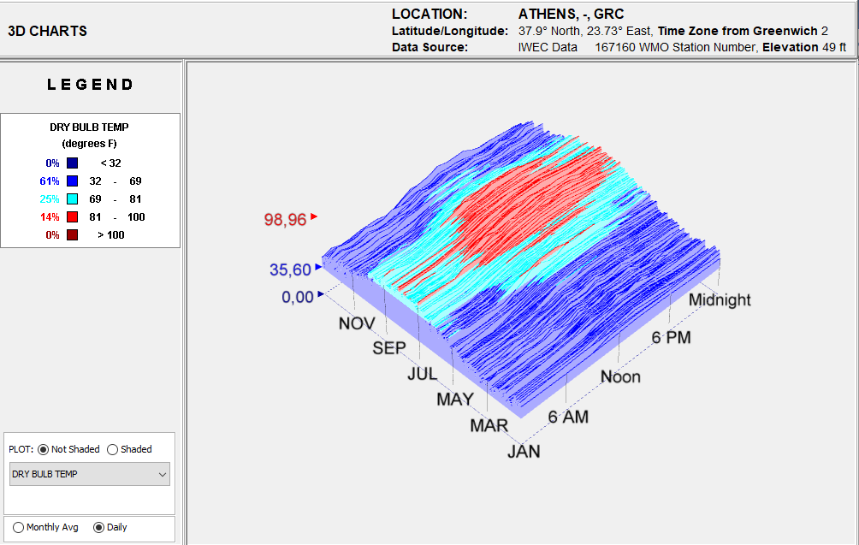

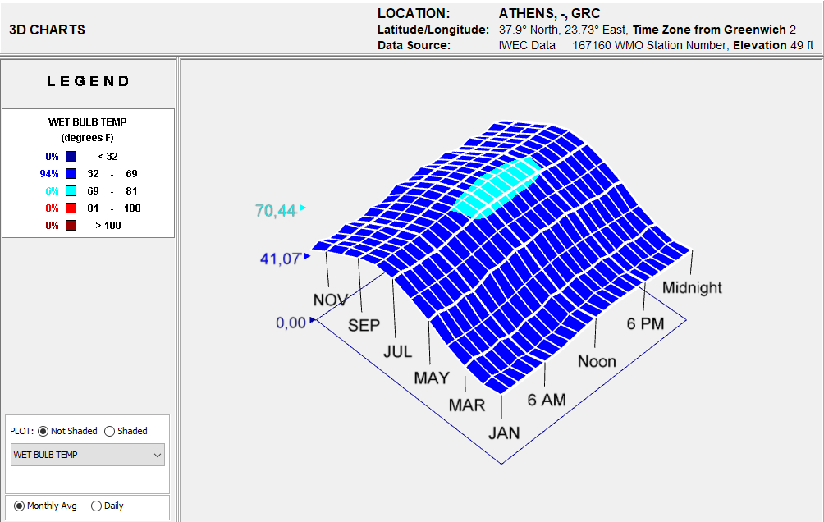

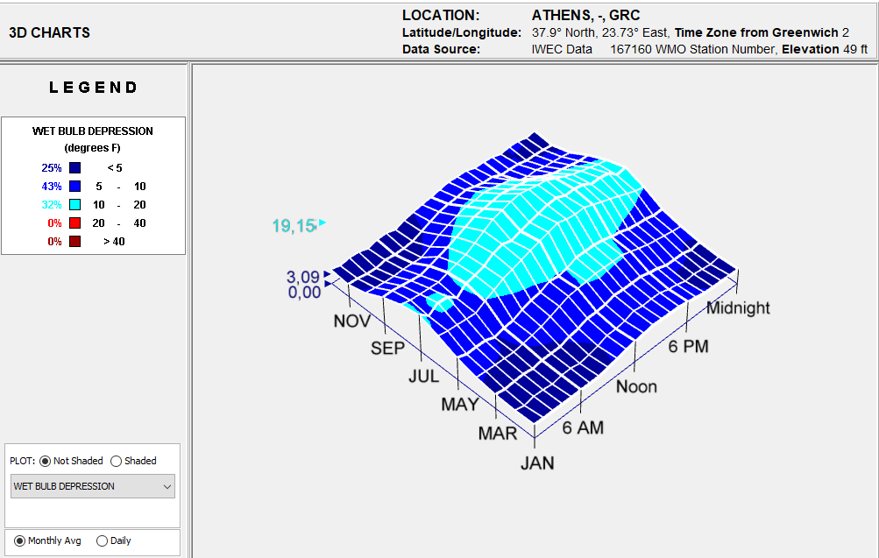
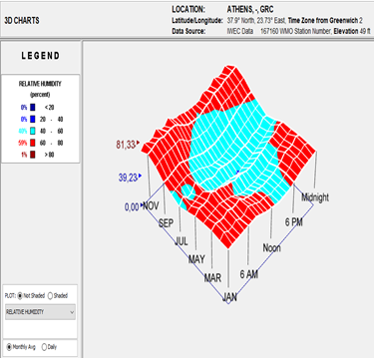
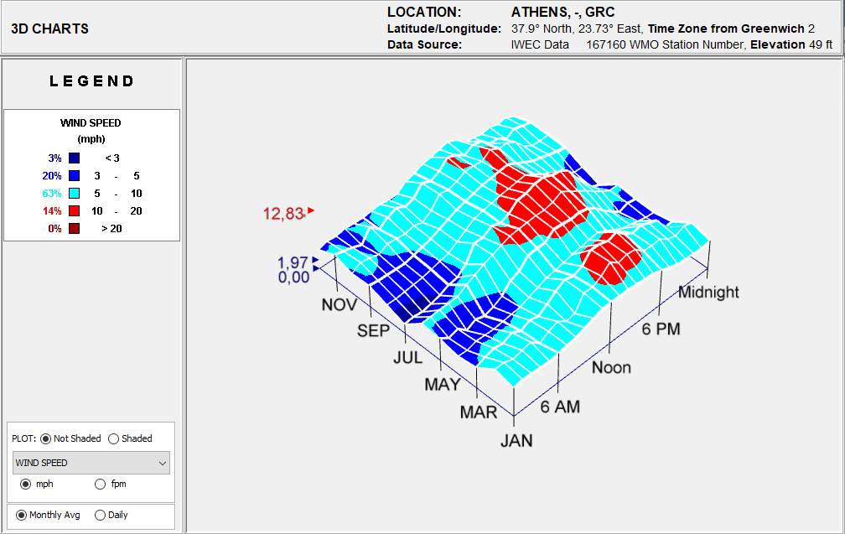
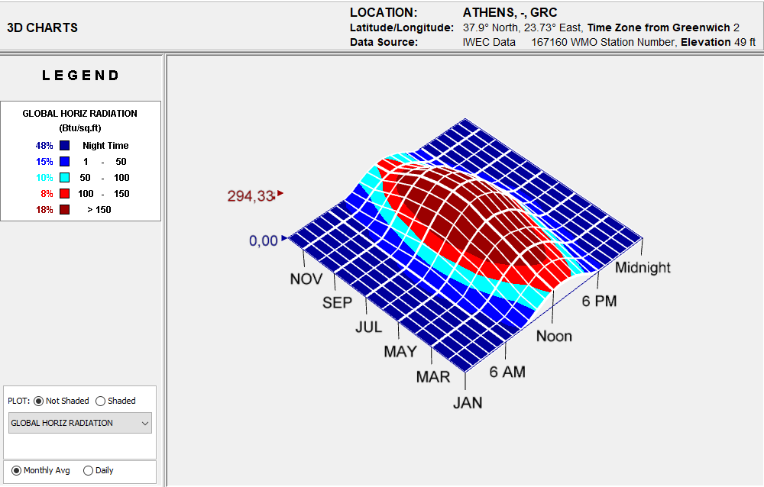
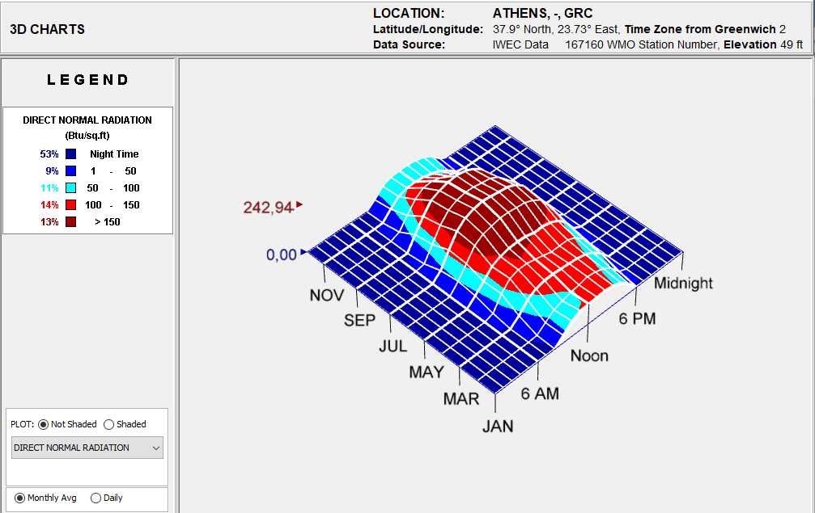

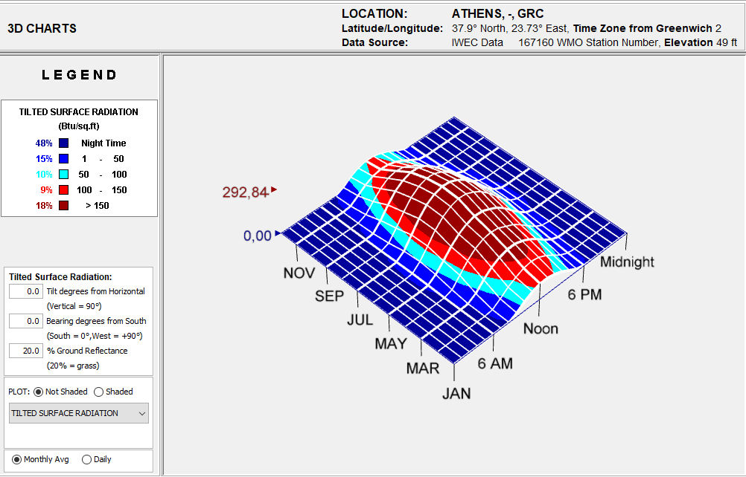
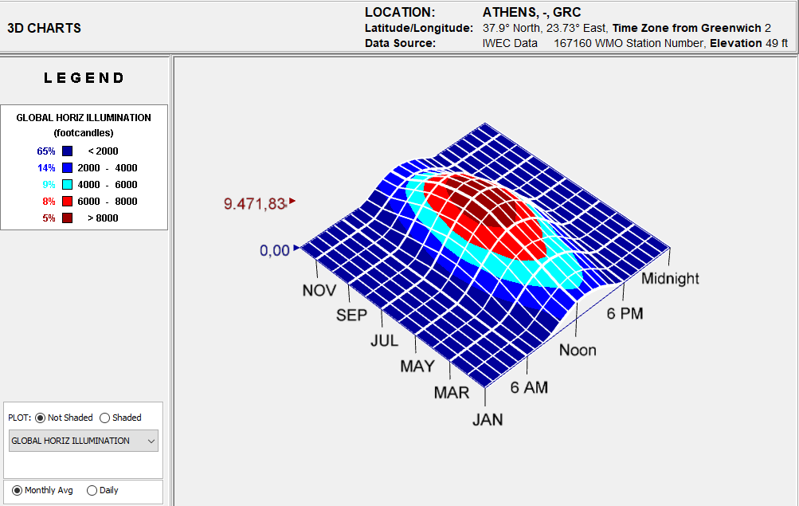

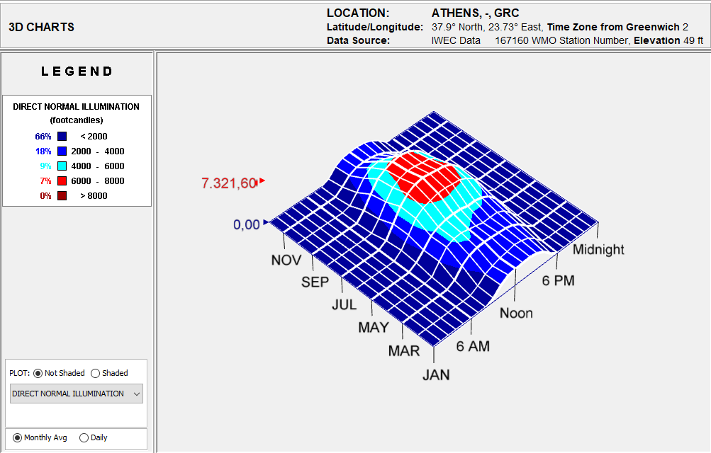

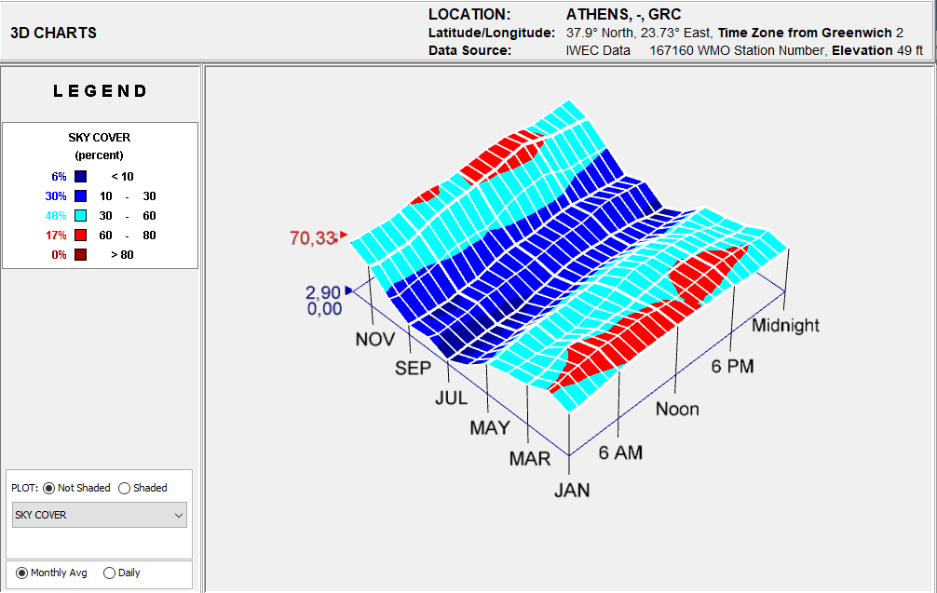
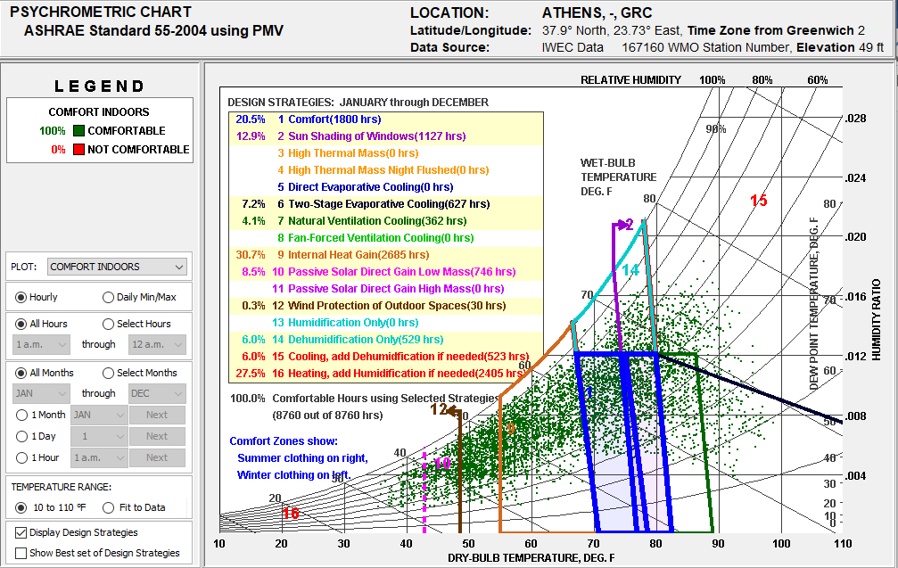

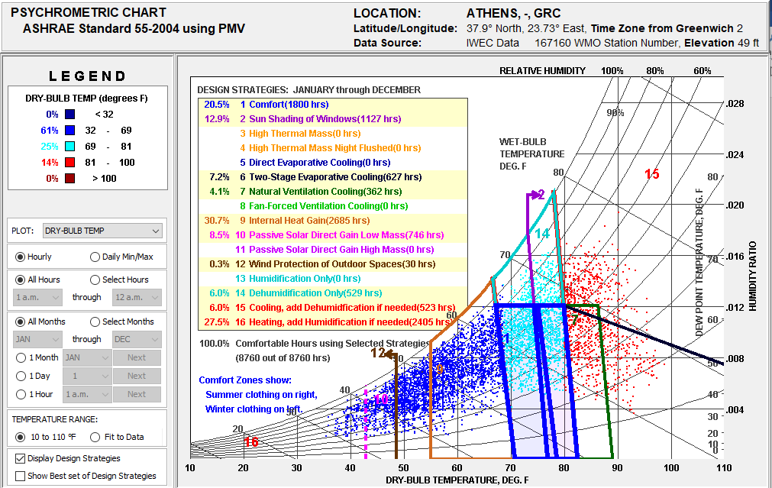

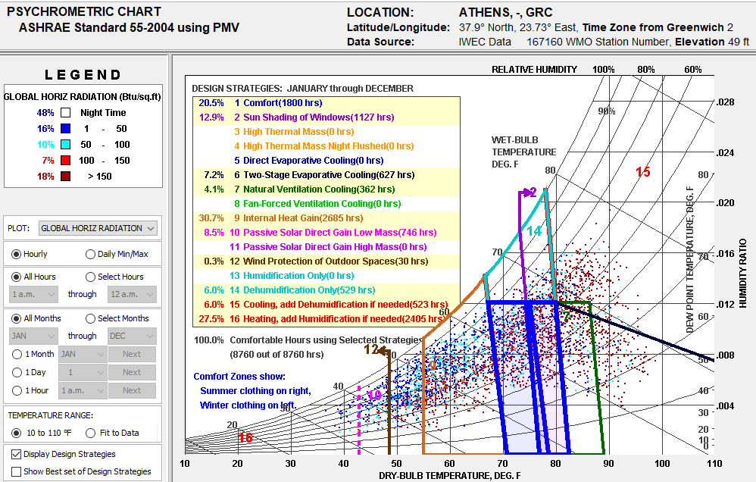
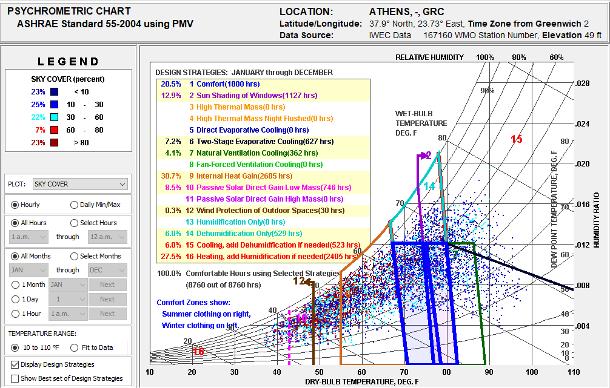

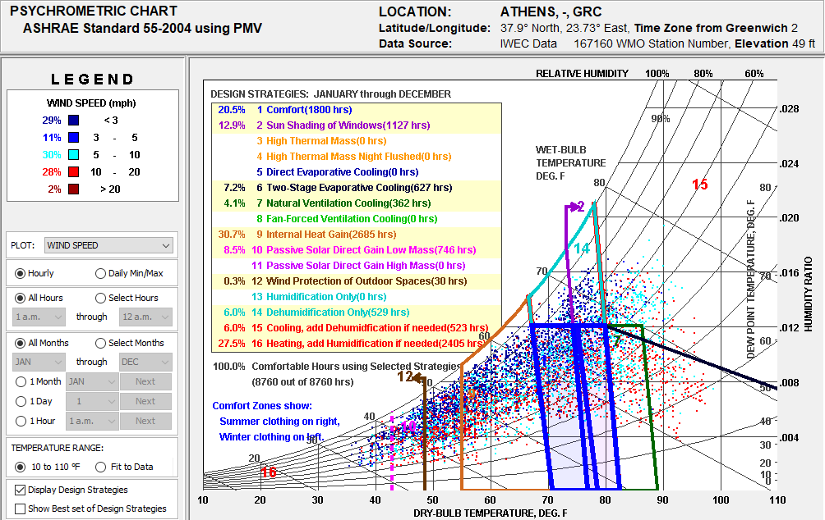
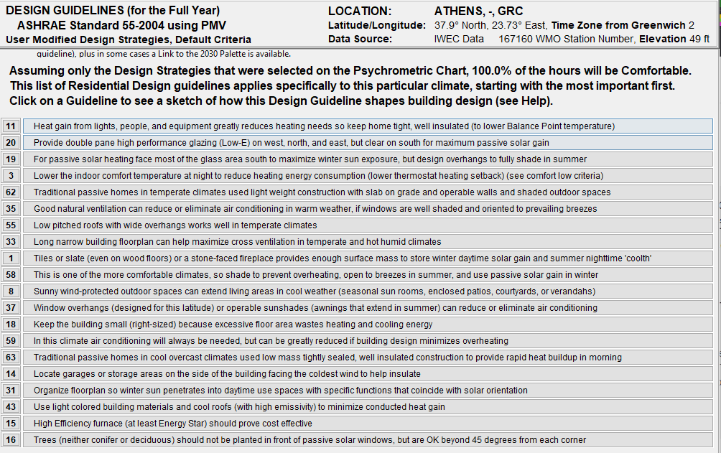
Residential Scale Homes are smaller buildings in which occupant thermal comfort is dominated by the design of the building shell (envelope dominated). Design Sketches are available for each of the Design Guidelines displayed (click on a guideline), plus in some cases a Link to the 2030 Palette is available.

Assuming only the Design Strategies that were selected on the Psychrometric Chart, 100.0% of the hours will be Comfortable.
This list of Residential Design guidelines applies specifically to this particular climate, starting with the most important first.
Click on a Guideline to see a sketch of how this Design Guideline shapes building design (see Help).
Heat gain from lights, people, and equipment greatly reduces heating needs so keep home tight, well insulated (to lower Balance Point temperature)
Provide double pane high performance glazing (Low-) on west, north, and east, but clear on south for maximum passive solar gain
For passive solar heating face most of the glass area south to maximize winter sun exposure. but design overhangs to fully shade in summer
Lower the indoor comfort temperature at night to reduce heating energy consumption (lower thermostat heating setback) (see comfort low criteria)
Traditional passive homes in temperate climates used light weight construction with slab on grade and operable walls and shaded outdoor spaces
Good natural ventilation can reduce or eliminate air conditioning in warm weather, if windows are well shaded and oriented to prevailing breezes
Low pitched roofs with wide overhangs works well in temperate climates
Long narrow building floorplan can help maximize cross ventilation in temperate and hot humid climates
Tiles or slate (even on wood floors) or a stone-faced fireplace provides enough surface mass to store winter daytime solar gain and summer nighttime 'coolth*
This is one of the more comfortable climates, so shade to prevent overheating, open to breezes in summer, and use passive solar gain in winter Sunny wind-protected
outdoor spaces can extend living areas in cool weather (seasonal sun rooms, enclosed patios, courtyards, or verandahs)
Window overhangs (designed for this latitude) or operable sunshades (awnings that extend in summer) can reduce or eliminate air conditioning
Keep the building small (right-sized) because excessive floor area wastes heating and cooling energy
In this climate air conditioning will always be needed, but can be greatly reduced if building design minimizes overheating
Traditional passive homes in cool overcast climates used low mass tightly sealed, well insulated construction to provide rapid heat buildup in morning
Locate garages or storage areas on the side of the building facing the coldest wind to help insulate
Organize floorplan so winter sun penetrates into daytime use spaces with specific functions that coincide with solar orientation
Use light colored building materials and cool roofs (with high emissivity) to minimize conducted heat gain
High Efficiency furnace (at least Energy Star) should prove cost effective
Trees (neither conifer or deciduous) should not be planted in front of passive solar windows, but are OK beyond 45 degrees from each corner
outdoor spaces can extend living areas in cool weather (seasonal sun rooms, enclosed patios, courtyards, or verandahs)
Window overhangs (designed for this latitude) or operable sunshades (awnings that extend in summer) can reduce or eliminate air conditioning
Keep the building small (right-sized) because excessive floor area wastes heating and cooling energy
In this climate air conditioning will always be needed, but can be greatly reduced if building design minimizes overheating
Traditional passive homes in cool overcast climates used low mass tightly sealed, well insulated construction to provide rapid heat buildup in morning
Locate garages or storage areas on the side of the building facing the coldest wind to help insulate
Organize floorplan so winter sun penetrates into daytime use spaces with specific functions that coincide with solar orientation
Use light colored building materials and cool roofs (with high emissivity) to minimize conducted heat gain
High Efficiency furnace (at least Energy Star) should prove cost effective
Trees (neither conifer or deciduous) should not be planted in front of passive solar windows, but are OK beyond 45 degrees from each corner
