MSC IN ANALYSIS AND DESIGN OF EARTHQUAKE RESISTANT STRUCTURES (ADERS)
Course: Geotechnical Engineering in the Design of Structures

PROJECT: Diaphragm wall analysis

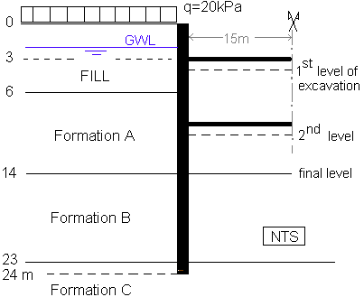

Soil | Unit weight  (KN/m³) | Young’s modulus  E (MPa) | Friction Angle  φ΄(degrees) | Cohesion intercept  c΄ (kPa) | Permeabi-lity  (m/s)
Fill | 21 | 10 | 33 | 0 | 10⁻⁴-10⁻⁶
Formation A | 19 | 15 | 30 | 0 | 10⁻⁵
Formation B | 20 | 30 | 30 | 5 | 5x10⁻⁷
Formation C | 19 | 50 | 33 | 15 | 5x10⁻⁷
Table 1: Soil characteristics

Excavation depth (m) | Dewatering depth (m) | Prop number | Depth (m) | Area (m²) | Moment of inertia (m⁴)
4 | 5 | 1 | 3 | 218x10⁻⁴ | 6.6x10⁻⁴
10 | 11 | 2 | 9 | 354x10⁻⁴ | 36.0x10⁻⁴
14 | 14 | - | - | - | -
Table 2: Excavation and water levels and prop levels and characteristics

